**Tic tac toe game**

**A Mini Project**

**Academic Year: 2021 - 22 ODDSEMESTER**

**Department with Specialization : B. Tech – Computer Science and**

**Engineering with Specialization in Artificial Intelligence and machine Learning**

**Semester : I**

**Course Code : 18CSS101J**

**Course Title : Programming and Problem**

**Solving**

*Submitted by*

**TATIREDDY ABHINAV REDDY [RA2111026010282]**

**GOTTAM SAIGANESH RAJU [RA2111026010283]**

*Under the Guidance of*

Dr. A. Suresh

(Associate Professor, NWC)



DEPARTMENT OF NETWORKING AND COMMUNICATIONS

COLLEGE OF ENGINEERING AND TECHNOLOGY

SRM INSTITUTE OF SCIENCE ANDTECHNOLOGY

KATTANKULATHUR- 603 203

FEBRUARY 2022

**Abstract for Tic Tac Toe Game project:**

**Tic-Tac-Toe game can be played by two players where the square block (3 x 3) can be filled with a cross (X) or a circle (O). The game will toggle between the players by giving the chance for each player to mark their move. When one of the players make a combination of 3 same markers in a horizontal, vertical or diagonal line the program will display which player has won, whether X or O. In this program, we implement a 3x3 tic-tac-toe game. The game is designed so that two players can play tic-tac-toe using C-language. The program will contain a display function and a select function to place the symbol as well as toggle between the symbols allowing each player a turn to play the game. The program will update after each player makes their move and check for the conditions of game as it goes on. Overall program works without any bugs and is able to use**

Algorithm

**Tic-Tac-Toe is a two player game where each player uses a signature. The player  who successfully places three respective signatures in a vertical, horizontal or  diagonal row is the winner**.

**Step 1:** Start

**Step 2:** Use 3 X 3 matrix to get 9 cell tic tac toe board.

**Step 3:** Signature 'X' is used for player 1 and 'Y' for player 2. And the players play  alternatively.

**Step 4:** Get index as input from the players. And the index range is from   cell 1 to cell 9.

**Step 5:** After each move, check whether that player has placed three respective  signatures in vertical, horizontal or diagonal row. If yes, declare that  particular player as winner.

**Step 6:** If no, give chance for other player.

**Step 7:** If all the cells in the Tic-Tac-Toe board got filled, then the game is drawn.

**Step 8:** End

**Flowchart**

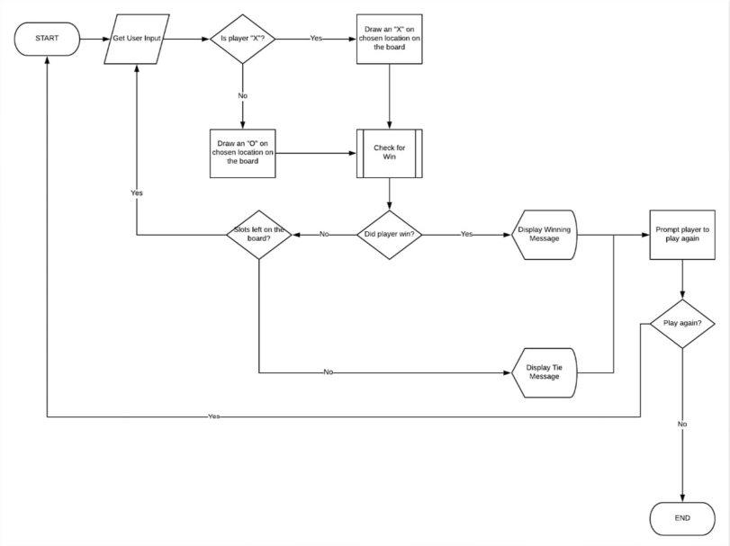

# Source Code

**#include <stdio.h>**

**char square[10] = { 'o', '1', '2', '3', '4', '5', '6', '7', '8', '9' };**

**int checkwin();**

**void board();**

**int main()**

**{**

**printf("***********************************************************************************************************************************\n");**

**printf("\t\t\t\t\t\t\tWELCOME\n");**

**printf("\t\t\t\t\t\t TIC TAC TOE GAME\n");**

**printf("\t\t\t\t\t\t\tDone by-'RA2111026010282' AND 'RA2111026010283'\n");**

**printf("***********************************************************************************************************************************\n");**

**int player = 1, i, choice;**

**char mark;**

**do**

**{**

**board();**

**player = (player % 2) ? 1 : 2;**

**printf("Player %d, enter a number: ", player);**

**scanf("%d", &choice);**

**mark = (player == 1) ? 'X' : 'O';**

**if (choice == 1 && square[1] == '1')**

**square[1] = mark;**

**else if (choice == 2 && square[2] == '2')**

**square[2] = mark;**

**else if (choice == 3 && square[3] == '3')**

**square[3] = mark;**

**else if (choice == 4 && square[4] == '4')**

**square[4] = mark;**

**else if (choice == 5 && square[5] == '5')**

**square[5] = mark;**

**else if (choice == 6 && square[6] == '6')**

**square[6] = mark;**

**else if (choice == 7 && square[7] == '7')**

**square[7] = mark;**

**else if (choice == 8 && square[8] == '8')**

**square[8] = mark;**

**else if (choice == 9 && square[9] == '9')**

**square[9] = mark;**

**else**

**{**

**printf("Invalid move ");**

**player--;**

**getch();**

**}**

**i = checkwin();**

**player++;**

**}while (i == - 1);**

**board();**

**if (i == 1)**

**printf("==>\aPlayer %d win ", --player);**

**else**

**printf("==>\aGame draw");**

**getch();**

**return 0;**

**}**

**int checkwin()**

**{**

**if (square[1] == square[2] && square[2] == square[3])**

**return 1;**

**else if (square[4] == square[5] && square[5] == square[6])**

**return 1;**

**else if (square[7] == square[8] && square[8] == square[9])**

**return 1;**

**else if (square[1] == square[4] && square[4] == square[7])**

**return 1;**

**else if (square[2] == square[5] && square[5] == square[8])**

**return 1;**

**else if (square[3] == square[6] && square[6] == square[9])**

**return 1;**

**else if (square[1] == square[5] && square[5] == square[9])**

**return 1;**

**else if (square[3] == square[5] && square[5] == square[7])**

**return 1;**

**else if (square[1] != '1' && square[2] != '2' && square[3] != '3' &&**

**square[4] != '4' && square[5] != '5' && square[6] != '6' && square[7]**

**!= '7' && square[8] != '8' && square[9] != '9')**

**return 0;**

**else**

**return - 1;**

**}**

**void board()**

**{**

**printf("\n\n\tTic Tac Toe\n\n");**

**printf("Player 1 (X) - Player 2 (O)\n\n\n");**

**printf(" | | \n");**

**printf(" %c | %c | %c \n", square[1], square[2], square[3]);**

**printf("_____|_____|_____\n");**

**printf(" | | \n");**

**printf(" %c | %c | %c \n", square[4], square[5], square[6]);**

**printf("_____|_____|_____\n");**

**printf(" | | \n");**

**printf(" %c | %c | %c \n", square[7], square[8], square[9]);**

**printf(" | | \n\n");**

**}**

**Screenshots**

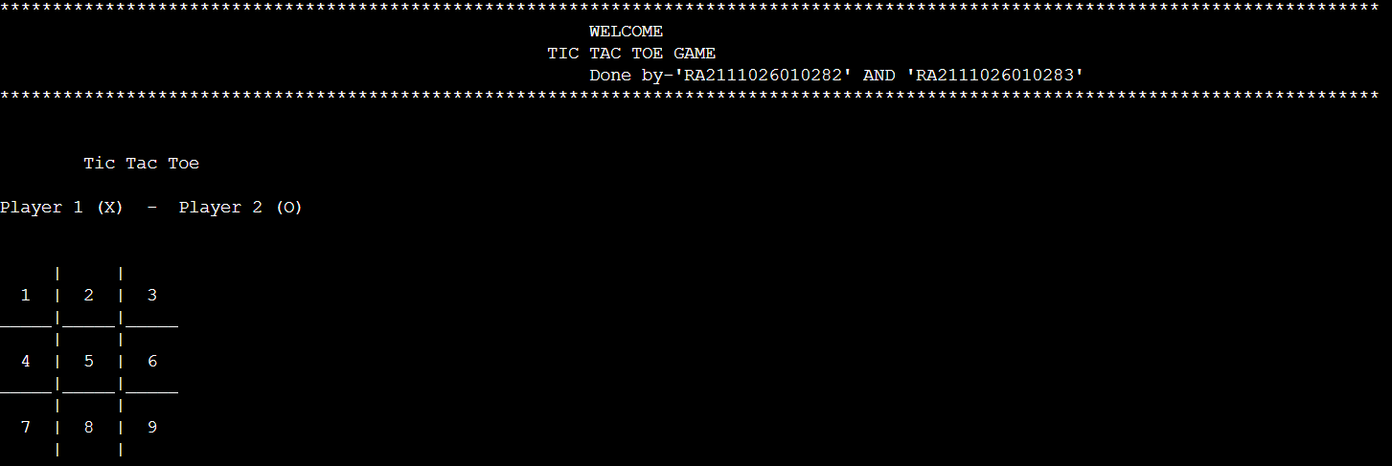

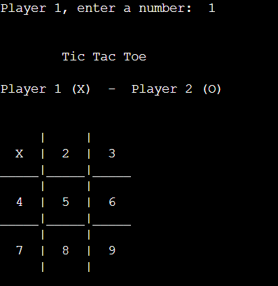

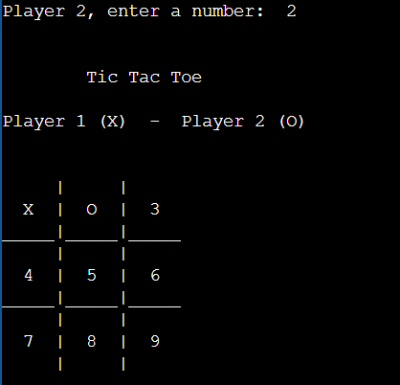

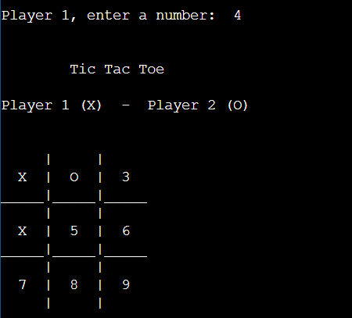

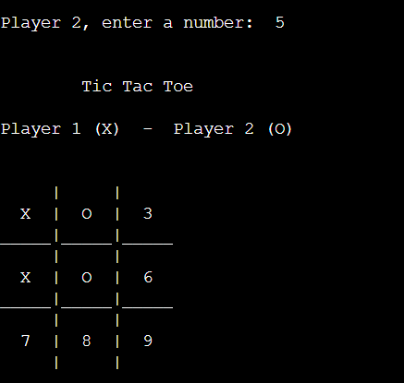

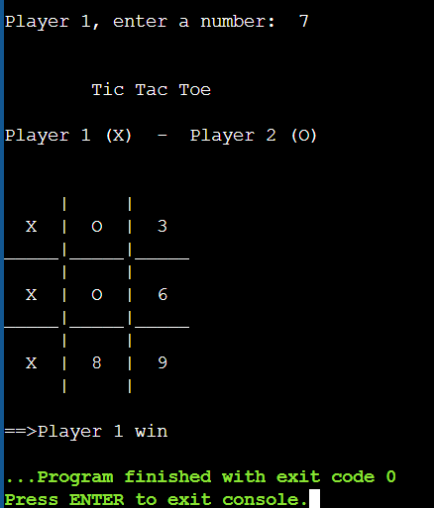

**Result:**

**The Tic Tac Toe game is most familiar among all the age groups. Intelligence can be a property of any purpose-driven decision maker. This basic idea has been suggested many times. An algorithm of playing Tic Tac Toe has been presented and tested that works in efficient way. Overall, the system works without any bugs.**

**Conclusion:**

We make Tic Tac Toe game successfully with the help of C language and it is very entertaining.